Introduction:

The sun is the ultimate source of all renewable energy on Earth. It provides a constant stream of energy in the form of solar radiation, which can be harnessed in various ways to generate electricity and heat. Unlike non-renewable energy sources such as fossil fuels, which are finite and contribute to climate change, the sun's energy is inexhaustible and does not produce harmful emissions.

One of the most popular methods of harnessing the sun's energy is through the use of solar panels. These panels contain photovoltaic cells that convert sunlight into electricity. The electricity generated by solar panels can be used to power homes, businesses, and even entire cities.

Another way to harness the sun's energy is through the use of solar thermal technology, which uses mirrors to concentrate sunlight and generate heat. This heat can then be used to power steam turbines, which generate electricity. Solar thermal technology can also be used to heat water for homes and businesses.

The sun's energy can also be used for passive heating and cooling. By designing buildings with large windows and proper insulation, the sun's heat can be used to warm indoor spaces during the day. At night, the same buildings can be designed to release the heat and keep the space cool.

In conclusion, the sun's energy is the source of all renewable energy on Earth. By harnessing this energy, we can generate electricity and heat without producing harmful emissions. As we work to transition to a more sustainable energy system, the sun will undoubtedly play a critical role in powering our world.

Problem Identification:

The need for renewable energy arises from the problems associated with our current energy sources. The majority of our energy comes from non-renewable sources such as coal, oil, and gas, which are finite resources and contribute to climate change and environmental degradation. These sources are also subject to price volatility and geopolitical conflicts, which can disrupt global energy markets.

The problem we are facing is the unsustainable use of non-renewable resources, which has resulted in the depletion of these resources and the emission of greenhouse gases that contribute to climate change. Burning fossil fuels releases carbon dioxide and other pollutants into the atmosphere, which trap heat and cause the Earth's temperature to rise. This results in rising sea levels, more frequent and severe weather events, and other harmful impacts on the environment and human health.

Renewable energy offers a solution to these problems. Renewable energy sources such as solar, wind, hydropower, and geothermal are sustainable and do not emit greenhouse gases, making them a clean and renewable source of energy. Renewable energy also offers the potential for energy independence and improved energy security by reducing our dependence on foreign oil and gas.

In addition to the environmental benefits, renewable energy also offers economic benefits. The growth of the renewable energy sector has the potential to create new jobs and spur economic development, particularly in rural areas where renewable energy resources are abundant. Renewable energy also offers cost savings over the long term, as the costs of renewable energy technologies continue to decrease and become more competitive with fossil fuels.

In conclusion, the need for renewable energy arises from the problems associated with our current energy sources. The unsustainable use of non-renewable resources is leading to environmental degradation and climate change. Renewable energy offers a sustainable and clean source of energy, with economic benefits and potential for energy independence. To address the challenges we face, we must continue to invest in and promote the growth of renewable energy technologies.

Concentrated solar power (CSP):

Concentrated solar power (CSP) is a type of solar energy technology that uses mirrors or lenses to focus sunlight onto a small area, creating a high concentration of heat that can be used to generate electricity. The process of generating electricity with CSP typically involves four main components: the solar field, the heat transfer system, the power block, and the thermal storage system.

The solar field is the area where the mirrors or lenses are located, and it is designed to track the movement of the sun throughout the day to maximize the amount of sunlight that is captured. The mirrors or lenses are arranged in a way that reflects the sunlight onto a receiver, which is typically located at the top of a tower or in a parabolic trough.

The receiver is responsible for absorbing the concentrated sunlight and converting it into heat, which is then transferred to a fluid such as water or molten salt through a series of tubes. The heat transfer system is responsible for carrying the hot fluid to the power block, where the heat is used to generate steam.

The power block is the area where the steam is used to power a turbine, which in turn generates electricity. The thermal storage system is responsible for storing excess heat generated during peak hours, which can be used to generate electricity during times when there is no sunlight available. The stored heat is typically used to heat a fluid, such as molten salt, which can retain heat for extended periods of time.

CSP has several advantages over other types of solar energy technologies. One of the main advantages is that it can be used to generate electricity even when the sun is not shining, thanks to the thermal storage system. Additionally, CSP systems can be designed to be very efficient and to generate large amounts of electricity, making it a viable option for utility-scale power generation. Finally, CSP systems can be designed to be very reliable and to have a long lifespan, making them a good option for long-term investment in sustainable energy.

In conclusion, concentrated solar power is a promising technology that has the potential to provide a significant amount of clean and renewable energy. By focusing sunlight onto a small area, CSP systems are able to generate a high concentration of heat, which can be used to generate electricity in a variety of ways. With the right investments in research and development, CSP has the potential to become a key component of a sustainable energy system.

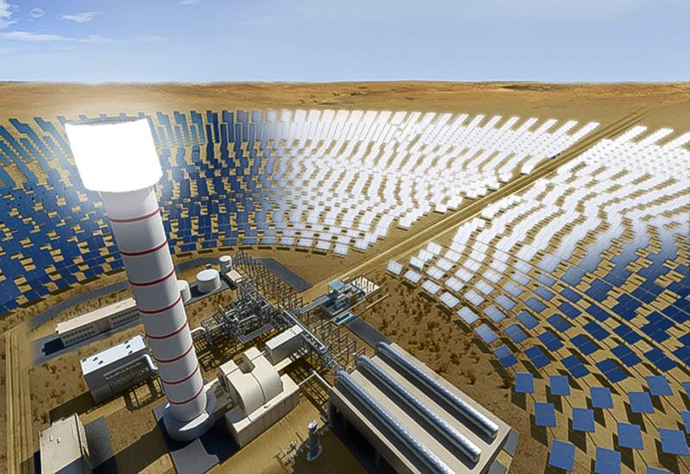

Passive Heating and Cooling:

Passive solar heating and cooling is a technique that uses the energy of the sun to provide indoor thermal comfort without the need for active mechanical systems. The basic idea is to design buildings that are optimized to absorb, store, and distribute the sun's energy, depending on the season and time of day. There are several strategies that can be used to achieve this, including direct gain, indirect gain, and isolated gain.

Direct gain is a strategy that involves using windows and other transparent materials to let the sun's heat directly enter the building. This can be achieved by positioning the windows in a way that maximizes the amount of sunlight that enters the building during the winter, when the sun is low on the horizon, and minimizes the amount of sunlight that enters the building during the summer, when the sun is high on the horizon. The sunlight that enters the building can be absorbed by thermal mass, such as concrete or water, and released into the building as heat as the temperature cools.

Indirect gain is a strategy that involves using thermal mass to absorb and store the sun's heat, and then releasing it into the building over time. This can be achieved by positioning thermal mass, such as concrete walls or floors, in a way that allows them to absorb sunlight during the day and release it into the building at night when the temperature drops.

Isolated gain is a strategy that involves using a separate system, such as a sunspace or a solarium, to capture and store the sun's heat. The sunspace is essentially a greenhouse-like structure that is designed to absorb and store the sun's heat during the day, and then release it into the building at night.

Passive cooling can also be achieved using similar strategies. For example, shading devices such as overhangs and external louvers can be used to prevent direct sunlight from entering the building during the summer, while still allowing for natural daylight. Natural ventilation can also be used to circulate cool air throughout the building, which can be achieved by using windows and strategically positioned vents to create a cross breeze.

In conclusion, passive solar heating and cooling is a simple and effective way to utilize the sun's energy for indoor thermal comfort without the need for mechanical systems. By designing buildings with the sun's energy in mind, we can reduce our reliance on non-renewable energy sources and create a more sustainable future.

Thermal energy storage:

Thermal energy storage (TES) is a method of storing heat or cold in materials such as water, ice, or molten salt for later use. The stored energy can be used for heating or cooling during periods of high demand or when there is no renewable energy available. TES is an effective method of energy storage and can be used in conjunction with renewable energy sources such as solar power.

There are several types of TES systems, including sensible heat storage, latent heat storage, and thermochemical storage. Sensible heat storage involves storing heat directly in a material such as water or rocks, which can be used later for heating or cooling. Latent heat storage involves storing heat by changing the phase of a material such as water or paraffin, which can release heat when the material changes back to its original phase. Thermochemical storage involves storing heat by chemical reactions that can release heat when the reaction is reversed.

One of the most common applications of TES is in building heating and cooling systems. In these systems, the stored heat or cold can be used to regulate indoor temperatures during periods of high demand or when there is no renewable energy available. TES can also be used in industrial processes such as steel production or power generation, where large amounts of heat are required.

TES has several advantages over other methods of energy storage. For example, it can store large amounts of energy and can be used in a variety of applications. It also has a high energy density, which means that it can store a large amount of energy in a small volume. Additionally, TES systems are generally low-maintenance and have a long lifespan, making them a cost-effective solution for energy storage.